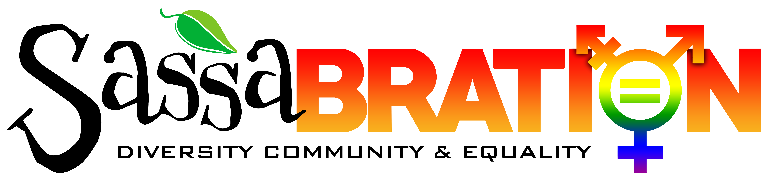
Summer 2022

Greetings Community Supporter:

We are excited to announce the 6th Annual Sassabration event, taking place on Saturday September 17th, 2022, from 12pm to 6pm, at 1500 Old Hot Springs Road, and we would like to invite you to become an important event sponsor. Since our inception in 2015, Sassabration has become a well-known event in Carson City and surrounding Northern Nevada communities, but we want to get bigger and better in 2022 –and we would appreciate your help!

Our mission is to support equality, diversity and community by hosting this annual fundraiser for local organizations that support the LGBTQ community. It is a family friendly event featuring live music, performance artists, food and vendors. Since 2015, we have raised more than $12,000 for local charitable organizations. Our goal this year is to raise even more much-needed funds which will benefit the following organizations: PFLAG Carson Region, The Ron Wood Family Resource Center and CASI (Carson Animal Services Initiative).

Through their mission of support, education and advocacy, PFLAG works to make sure the LGBTQ community, and their families, are safe and secure wherever they live, work, study or worship. The goal of the Ron Wood Family Resource Center is to create a lasting community wide cooperative effort between the private sector and governmental agencies to promote healthy family relationships through education and support services. CASI is an all-volunteer organization dedicated to supporting programs and services designed to reduce animal suffering and provide assistance to the community.

We cannot meet our goal without you. Would you consider donating an item for our silent auction or becoming a sponsor? Your generous and tax-deductible support will help us meet, or even exceed, our fundraising goal. We look forward to hearing from you.

Thank you for taking the time to consider our request and thanks so much for your generous support!

Jayme Watts, Director

Sassabration Inc.
c/o Sassafras Eclectic Food Joint
1500 Old Hot Springs Road
Carson City, NV 89706
775-884-4471
sassabration.com
sassabration@gmail.com

Sassabration Rainbow Sponsorship levels:
Please circle the color of the level that you are donating and return in the enclosed envelope. You will be contacted regarding your donation or please call with any questions.
All artwork should be sent to sassabration@gmail.com no later than August 10th, 2022

$1000 – Purple
- Vendor spot to promote your company. You must bring your own tent, weights & staff
- Business logo prominently displayed on our website and other promotional materials
- Basket of goodies

$500 – Green
- Vendor spot to promote your company. You must bring your own tent, weights & staff
- Business logo on promotional materials

$250 –Blue
- Business logo on promotional materials

Various $ - Orange
- Silent Auction Donation

Value: $______________________ Drop off or arrange for pickup?____________________________________

Description: ___________________________________________________________________________________________

- Other: __________________________________________________

Name of Donor/Company:___________________________________________________________________________________________

Contact Person(s):____________________________________________________________________________________________________

Address:___________________________________________________________City:______________________State:______Zip:________

Phone: ____________________________________Email:______________________________________________________________________

We encourage and welcome participation from everyone in our community and your generous donation is greatly appreciated!

Checks can be made payable to Sassabration Inc.
For donation pick up or any questions please contact:

Jayme Watts, Director
Sassabration Inc.
1500 Old Hot Springs Road
Carson City, NV 89706
775-297-5515 cell

