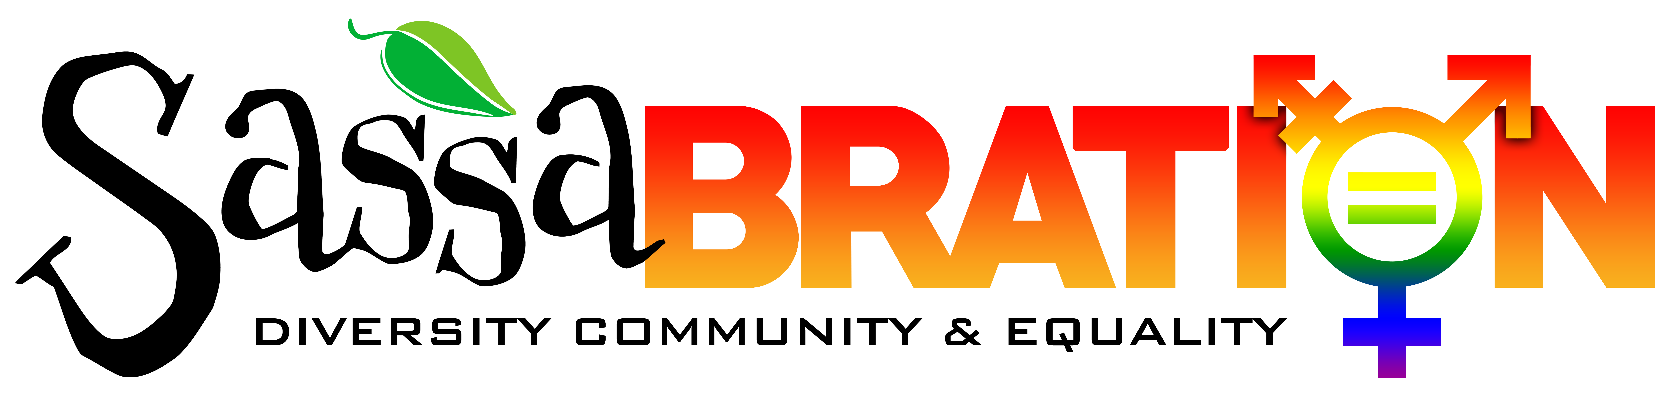Vendor Application 2022

Saturday September 17th 2022 12:00 p.m. – 6 p.m.
The event is located in the parking lot of Sassafras, The Carson Hot Springs and Shoe Tree Brewing
1500 Old Hot Springs Road, Carson City, Nevada 89706 775-884-4471

NAME OF BUSINESS: _______________________________________________________________________________________________________

CONTACT PERSON: _____________________________________ E-MAIL: ________________________________________________

MAILING ADDRESS: _____________________________________ CITY/STATE: _____________________________________ ZIP:______________

PHONE: _____________________________ CELL: ________________________________

STATE OF NEVADA RESALE TAX PERMIT # (ONLY IF REQUIRED) : _________________________________________

Check category:

􀀀 Nonprofit 􀀀 Entertainment 􀀀 Artisan/Crafter
􀀀 Political Organization 􀀀 Other:________________

BOOTH SIZE IS 10’X10’ UNLESS OTHER ARRANGEMENTS ARE MADE

Date & Time of Participation: Saturday September 17th 2022 12pm-6pm
We ask that you please plan on being at the event until at least 6pm. The event goes on outside until 8pm and vendors are welcome to stay until then if they choose.

Please provide a concise general description of your booth, items to be sold, information that will be passed out,
anything that applies to your booth. ____________________________________________________________________________________________________________________________________________________________________________________________________________
______________________________________________________________________________________________________

Booth Fees

The fee schedule for this event is $75 until August 31st 2022. Fees will increase by $20 per week after that date. Payment can be made in the form of cash, check or cashiers check and is due when the application is submitted. Non-profits are eligible to receive a reduced fee. Please provide a copy of the current 501(c)(3) paperwork.

Sassabration Inc. donates 100% of the vendor booth fees and silent auction donations to our designated organizations. Any donation of a silent auction item is greatly appreciated!

Vendors are responsible for securing their own booths
PLEASE BRING WEIGHTS FOR YOUR POP-UPS!
Any Correspondence should be directed to:
Sassabration Inc. c/o Jayme Watts
1500 Old Hot Springs Road
Carson City, NV 89706
775-884-4471
sassabration@gmail.com

Sassabration Inc. reserves the right to deny any application

HOLD HARMLESS / INDEMNIFICATION AGREEMENT
Sassabration Inc.

In consideration of acceptance of the applicant’s (“Applicant”) application to participate in the Sassabration (“Event”), the Applicant (its officers, directors, agents, employees, representatives, and/or members) agrees to indemnify, hold harmless, protect, and defend the Sassabration as well as entities’ agents, employees, and/or representatives, from and against any and all loss, claim of loss, injury (including, but not limited to, personal injury), damage (including, but not limited to, property damage), liability, or other expense (including, but not limited to, reasonable attorneys’ fees and court costs), claimed by
or resulting from a claim by a third party or the Applicant (or any officer, director, agent, employee, representative, and/or member of the Applicant), that arises out of, or is in any manner, related to
any act or failure to act by the Applicant (its officers, directors, agents, employees, representatives,
and/or members) in connection with the Applicant’s participation in this Event.

I / We hereby affirm that I / we have read and understand the Rules and Regulations, and the
Hold Harmless / Indemnification Agreement and agree to the terms expressed therein.

The undersigned has read this Agreement carefully and represents that they have the authority
to execute this Agreement on behalf on behalf of the party or parties (meaning anyone in or associated with their booth)
they are signing.

___________________________________________
Name of Business or Organization (Please print)

___________________________________________ ____________________
Applicant(s) Signature Date

Revised June 20, 2022

